**DEVELOPMENT PART 1**

**PROJECT TITLE: SMART WATER MANAGEMENT SYSTEM**

**INTRODUCTION:**

1. Smart water management systems represent a crucial step forward in optimizing the way we handle and utilize water resources. These systems leverage advanced technologies to monitor, control, and enhance the efficiency of water usage across various sectors. By integrating sensors, data analytics, and communication technologies, smart water management systems provide real-time insights and enable intelligent decision-making to ensure sustainable water practices. From residential to industrial settings, these systems play a pivotal role in addressing water scarcity challenges and promoting conservation. Overall, the introduction of smart water management is a watershed moment (pun intended!) in our quest for a more responsible and sustainable approach to water resources.
2. A Smart Water Management System (SWMS) is a sophisticated and integrated solution designed to monitor, control, and optimize water usage in various environments. As water scarcity becomes a global concern, the need for efficient water management systems has grown significantly. SWMS leverages advanced technologies, data analytics, and automation to enhance the overall management of water resources.

**ALGORITHM:**

Step1: Start

Step2: Find a user-friendly platform for user convenient.

Step3: Collect the Data from Variety of Sources such as Sensors, Smart meters , and Weather forecasts,etc.

Step4: Analyze the Data.

Step5: Connect the sources (sensors,weather forecast,etc) to the given Board like Arduino UNO, Raspberry pi ,etc.

Step6: Make a decision like allocate the water supply.

Step7: Check the Board Connection and Run the code.

**IDEA FOR THE SOLUTION:**

Smart water management systems (SWMS) offer a comprehensive approach to optimizing water usage and conservation efforts. These solutions encompass a range of innovative technologies and strategies that can be tailored to specific needs and environments. Here are some key ideas for implementing effective SWMS solutions:

1. **Real-time monitoring and data analytics:** Deploy a network of sensors throughout the water infrastructure to collect real-time data on water flow, pressure, quality, and consumption patterns. Utilize data analytics tools to process and interpret this information, providing insights into potential leaks, inefficiencies, and areas for improvement.
2. **Leak detection and prevention:** Employ advanced leak detection technologies, such as acoustic sensors and pressure monitoring systems, to identify leaks promptly and accurately. Implement proactive leak prevention measures, including infrastructure maintenance programs and pressure management strategies.
3. **Demand-based water management:** Implement smart metering systems that provide detailed water usage data for individual consumers or specific areas. Utilize this data to implement demand-based pricing structures and encourage water conservation practices.
4. **Smart irrigation systems:** Implement intelligent irrigation systems that adjust watering schedules based on real-time weather data, soil moisture sensors, and plant water requirements. This approach optimizes water usage for landscaping and agriculture, reducing waste and conserving resources.
5. **Water quality monitoring and treatment:** Utilize real-time water quality monitoring systems to detect potential contaminants and ensure adherence to safety standards. Implement smart control systems for water treatment processes, optimizing chemical dosing and ensuring effective purification.
6. **Predictive maintenance and risk mitigation:** Leverage machine learning algorithms to analyze historical data and predict potential equipment failures or system disruptions. Implement preventive maintenance schedules and risk mitigation strategies to enhance system resilience and minimize downtime.
7. **Cybersecurity and data protection:** Employ robust cybersecurity measures to protect SWMS data and infrastructure from cyberattacks. Implement secure data transmission protocols, access controls, and intrusion detection systems to safeguard sensitive information.
8. **Community engagement and education:** Raise awareness about water conservation and the benefits of smart water management practices. Engage with communities and stakeholders to promote behavioral changes and encourage responsible water usage habits.
9. **Collaborative partnerships and data sharing:** Foster partnerships among water utilities, municipalities, and technology providers to share data, expertise, and best practices. Collaborative efforts can accelerate innovation and enhance the effectiveness of SWMS implementations.
10. **Continuous improvement and adaptability:** Implement a continuous improvement cycle for SWMS, incorporating feedback from users, analyzing performance data, and adapting to changing conditions. This approach ensures that the system remains effective and responsive to evolving needs.

**TOOLS AND TECHNOLOGIES:**

Smart water management systems (SWMS) utilize a variety of tools and technologies to monitor, analyze, and control water resources. Some of the most common tools and technologies used in SWMS include:

* **Sensors:** Sensors collect real-time data on water flow, pressure, quality, and other parameters. This data is essential for monitoring water systems, identifying leaks and other problems, and optimizing water usage.
* **Data analytics software:** Data analytics software is used to process and analyze sensor data. This software can identify patterns and trends in the data, which can be used to improve water system performance and efficiency.
* **Machine learning algorithms:** Machine learning algorithms are used to predict water demand, identify potential leaks, and optimize water treatment processes. Machine learning can also be used to develop personalized water conservation recommendations for consumers.
* **Control systems:** Control systems are used to automate actions based on the insights gained from data analytics and machine learning. For example, control systems can be used to adjust water pressure, open and close valves, and turn on and off pumps.

In addition to these core tools and technologies, SWMS may also incorporate other technologies such as:

* **Internet of Things (IoT) platforms:** IoT platforms provide a way to connect sensors, devices, and software applications to the cloud. This enables real-time data sharing and collaboration among different stakeholders in the water management process.
* **Geographic information systems (GIS):** GIS can be used to visualize and analyze water system data on a map. This can help to identify potential problems, such as leaks near critical infrastructure or areas with high water demand.
* **Decision support systems (DSS):** DSS provide water managers with tools to support decision-making. These systems can incorporate data analytics, machine learning, and GIS to help managers to evaluate different options and make informed decisions about water resource management.

The specific tools and technologies used in a SWMS will vary depending on the specific needs and resources of the organization. However, the core technologies listed above are essential for developing and implementing effective SWMS solutions.

Here are some examples of how specific tools and technologies are being used in SWMS today:

* **Smart water meters:** Smart water meters provide real-time data on water usage, which can be used to identify leaks and reduce water waste.
* **Acoustic leak detection systems:** Acoustic leak detection systems use microphones to detect the sound of water leaks. These systems can be used to identify leaks that are difficult to find with traditional methods.
* **Pressure monitoring systems:** Pressure monitoring systems can be used to detect changes in water pressure, which can be an indication of a leak or other problem.
* **Water quality monitoring systems:** Water quality monitoring systems can be used to monitor water quality for a variety of parameters, including pH, turbidity, and bacterial contamination.
* **Machine learning algorithms:** Machine learning algorithms are being used to predict water demand, identify potential leaks, and optimize water treatment processes. For example, machine learning algorithms can be used to predict water demand based on weather data and historical usage patterns.
* **Control systems:** Control systems are being used to automate water system operations, such as adjusting water pressure, opening and closing valves, and turning on and off pumps.

SWMS are rapidly evolving as new technologies and tools emerge. By leveraging these innovative solutions, water utilities and organizations can improve water efficiency, conservation, and resilience.

**BOARDS AND LANGUAGES:**

The boards and programming languages used in smart water management systems (SWMS) vary depending on the specific needs and requirements of the system. However, some of the most common boards and programming languages used in SWMS include:

**i) Boards:**

* Arduino: Arduino is a popular open-source electronics platform that is used for a wide variety of applications, including SWMS. Arduino boards are relatively inexpensive and easy to use, making them a good choice for developing and implementing SWMS prototypes.
* Raspberry Pi: Raspberry Pi is a low-cost, single-board computer that is also commonly used in SWMS. Raspberry Pi boards are more powerful than Arduino boards, making them a good choice for developing more complex SWMS solutions.
* BeagleBone: BeagleBone is another popular single-board computer that is used in SWMS. BeagleBone boards are similar to Raspberry Pi boards in terms of performance, but they offer some additional features, such as more GPIO pins and a faster processor.

**ii) Programming languages:**

* Python: Python is a general-purpose programming language that is popular for SWMS development. Python is easy to learn and use, and it offers a wide range of libraries and tools for developing SWMS applications.
* C/C++: C and C++ are low-level programming languages that are often used for developing performance-critical SWMS applications. C and C++ offer more control over hardware resources than Python, but they are also more difficult to learn and use.
* Java: Java is a general-purpose programming language that is sometimes used for SWMS development. Java is a good choice for developing cross-platform SWMS applications, but it can be slower than Python or C/C++.

The specific board and programming language used in a SWMS will vary depending on the specific needs and requirements of the system. However, the boards and programming languages listed above are a good starting point for developing and implementing SWMS solutions.

Here are some examples of how specific boards and programming languages are being used in SWMS today:

* Arduino: Arduino boards are often used to develop prototypes of SWMS solutions. For example, Arduino boards can be used to develop simple irrigation systems or water monitoring systems.
* Raspberry Pi: Raspberry Pi boards are often used to develop more complex SWMS solutions. For example, Raspberry Pi boards can be used to develop water distribution control systems or water quality monitoring systems.
* Python: Python is a popular programming language for developing SWMS applications. For example, Python can be used to develop applications for monitoring and controlling water distribution systems, irrigation systems, and water treatment systems.
* C/C++: C and C++ are often used for developing performance-critical SWMS applications. For example, C and C++ can be used to develop real-time control systems for water distribution systems or wastewater treatment plants.
* Java: Java is sometimes used for developing cross-platform SWMS applications. For example, Java can be used to develop applications for monitoring and controlling water systems from a variety of devices, such as smartphones, tablets, and laptops.

SWMS are rapidly evolving as new technologies and tools emerge. By leveraging these innovative solutions, water utilities and organizations can improve water efficiency, conservation, and resilience.

**PROGRAM:**

import time

import board

import analogio

import paho.mqtt.client as mqtt

# Define the pin for the water level sensor

water_level_sensor_pin = analogio.AnalogIn(board.A0)

# Define the MQTT broker address

mqtt_broker_address = "localhost"

# Define the MQTT topic

mqtt_topic = "water_level"

# Connect to the MQTT broker

client = mqtt.Client()

client.connect(mqtt_broker_address)

# Define a function to read the water level sensor value

def read_water_level():

# Read the water level sensor value

water_level_sensor_value = water_level_sensor_pin.value

# Convert the water level sensor value to a voltage

water_level_sensor_voltage = water_level_sensor_value * 5

# Convert the voltage to a water level

water_level = water_level_sensor_voltage / 10

# Return the water level

return water_level

# Start a loop to monitor the water level

while True:

# Read the water level

water_level = read_water_level()

# Publish the water level to the MQTT topic

client.publish(mqtt_topic, str(water_level))

# Wait for 1 second

time.sleep(1)

**BLOCK DIAGRAM:**

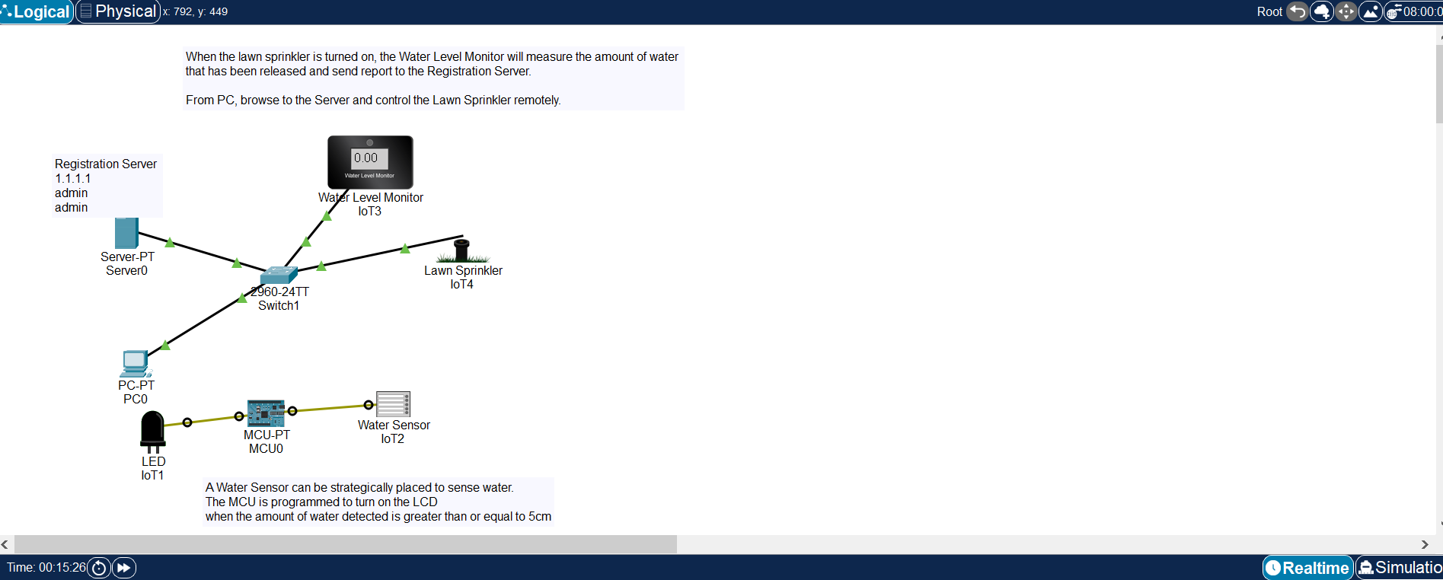

**CONCLUSION:**

Smart water management (SWM) is the use of technology to improve the efficiency, sustainability, and resilience of water resources. SWM systems can be used to monitor and manage water distribution networks, wastewater treatment plants, irrigation systems, and other water-related infrastructure.

SWM systems use a variety of sensors, data analytics tools, and machine learning algorithms to collect, analyze, and interpret data about water usage, quality, and flow. This information is then used to make informed decisions about how to manage water resources more effectively.